231901002 ADHIYAN

EXPNO:06

DATE:29.08.2024

**Customize Switch with Network Modules using Cisco Packet Tracer AIM:**

To Customize Switch with Network Modules using Cisco Packet Tracer

# 1. Open Cisco Packet Tracer

• Launch Cisco Packet Tracer on your computer.

**2. Add a Switch to Your Workspace** • In the device toolbar (usually on the left side of the screen), locate the "Switches" section.

• Drag and drop a switch model onto the workspace. For instance, you might choose a model like the "2950" or "2960."

# 3. Access the Switch’s Physical Layout

* Click on the switch in the workspace to open its configuration window.
* Navigate to the "Physical" tab to see the switch's physical layout and modules.

# 4. Add Network Modules

* In the "Physical" tab, you might see options to add or modify network modules.
* Click on the slot where you want to add a module. You can choose from available modules such as different types of Ethernet or Fiber modules.
* Drag the module from the list of available modules and drop it into the slot on the switch.

**5. Configure the Modules** • After adding the module, switch to the "Config" tab in the switch’s configuration window.

• Here, you can configure the ports provided by the module. For example, you can set IP addresses, VLAN configurations, and other settings for the new interfaces.

# 6. Configure the Switch Ports

* Switch to the "Config" tab to configure ports on the switch. Here, you can set parameters for each port.
* Select the specific port or range of ports you want to configure. You can set parameters such as VLAN assignments, port descriptions, and more.
* For example:

o To configure a port to be in a specific VLAN:

* + Select the port or range of ports.
  + Assign the VLAN ID under the VLAN settings. o To set a description for the port:
  + Enter a description in the "Description" field.

# 7. Using the CLI for Detailed Configuration

* Switch to the "CLI" tab for command-line interface access.
* Enter configuration commands to set up the switch. Here’s an example of how to configure VLANs and interface settings via CLI:

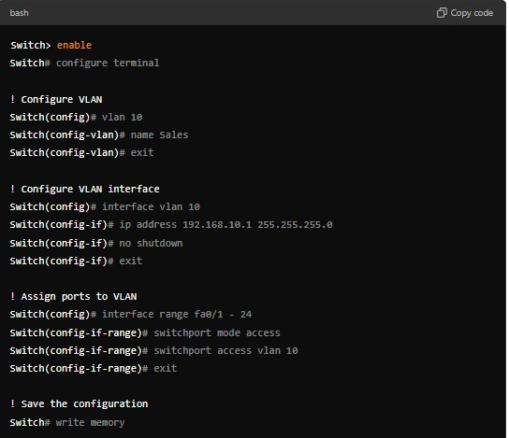

# 8. Save Your Configuration

• Once you’ve configured the modules and ports, be sure to save your configuration. Use commands in the CLI (Command Line Interface) if you’re using a model that supports CLI commands.

For example:

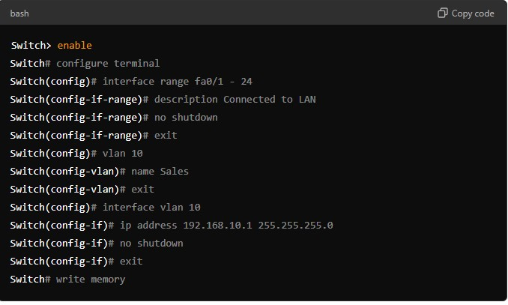

# 9. Test Your Configuration

* Use the simulation mode to test the network configuration.
* Add devices (PCs, routers, etc.) and connect them to the switch to ensure that everything is working as expected.

Output:

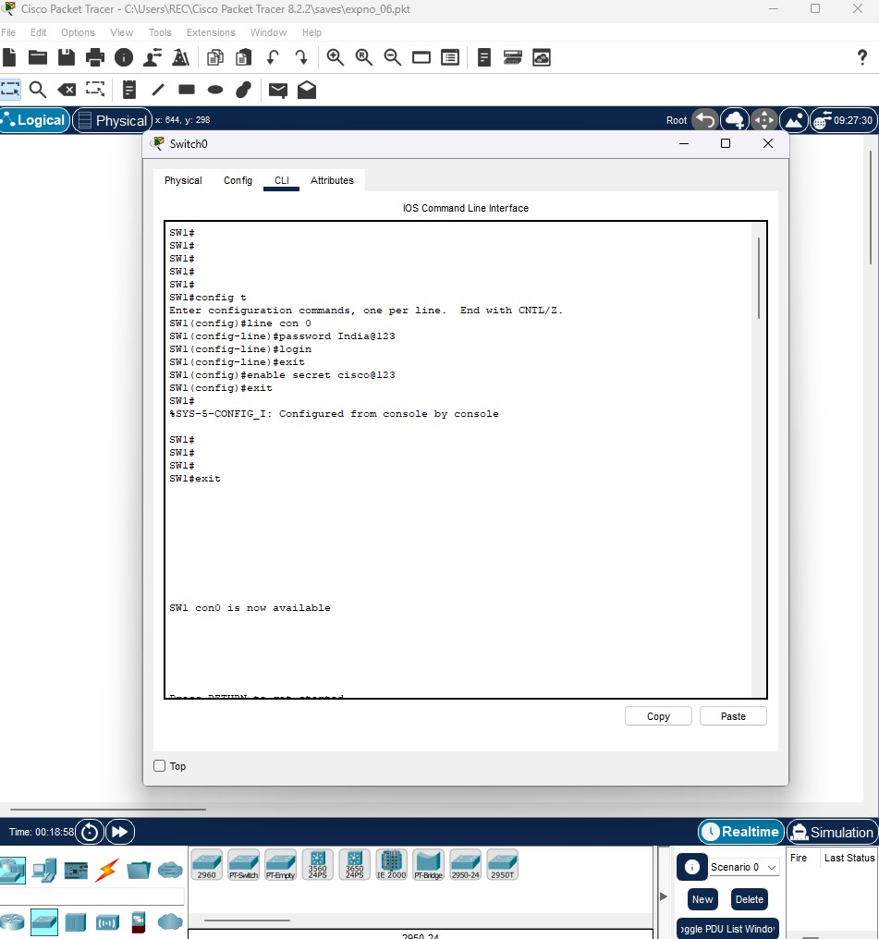

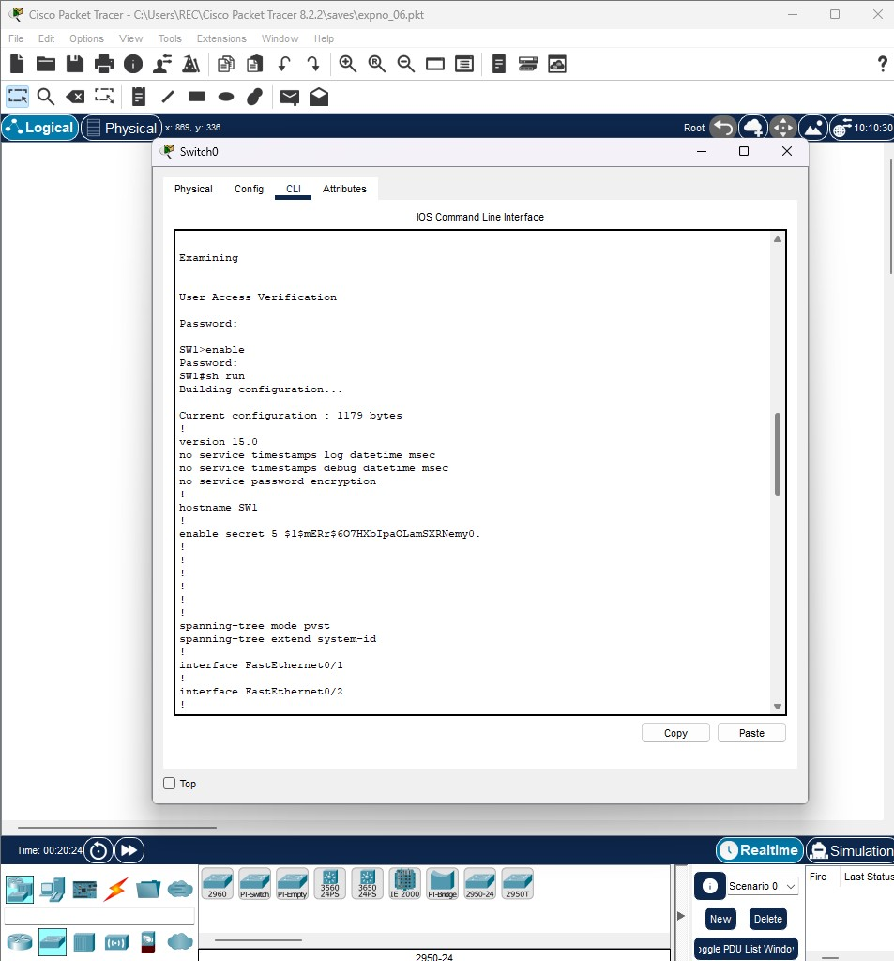

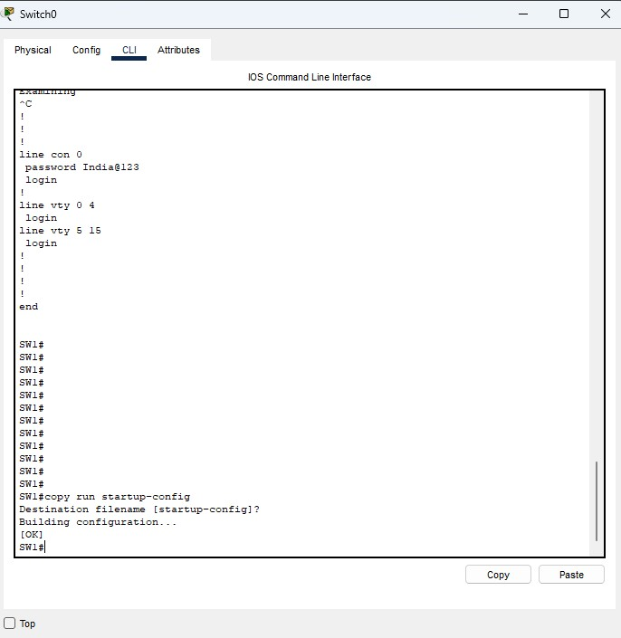

Result:

Switch with Network Modules using Cisco Packet Tracer is Customized.